Project
- Site-21-Api-Ng-Publishing-PostGres-Docker-Fallback
  - Copied from: Site-20-Api-Ng-PhotoManagement
- For the “MySocialConnect-SPA” issue npm install command to install all packages
  - ng serve : to run the spa

New & Updates
New | Updates
 | angular.json
 | /core/interceptors/loading.interceptor.ts
 | /core/services/signalr/message-hub.service.ts
 | /site/members/member-detail

Clear Database
If you want to clear database then drop it and recreate it
dotnet ef database drop
dotnet ef database update

Important – Follow WebApi Doc
Follow WebApi document to setup deployment.
Any angular steps do per instructions from this doc
020 Project21 -WebApi-Publishing-PostGres-Docker-Fallback.docx

Serve Angular From Api
The spa code will get published inside the MSC.WebApi, in a folder named wwwroot

angular.json
outputPath property updated
From | To
"architect": {  "build": {  "builder": "@angular-devkit/build-angular:browser",  "options": {  "outputPath": "dist/my-social-connect-spa",  "index": "src/index.html",  "main": "src/main.ts",  "polyfills": [  "zone.js"  ], | "architect": {  "build": {  "builder": "@angular-devkit/build-angular:browser",  "options": {  "outputPath": "../MySocialConnect-API/MSC.WebApi/wwwroot",  "index": "src/index.html",  "main": "src/main.ts",  "polyfills": [  "zone.js"  ],

Change budgets as well
From | To
"production": {  "budgets": [  {  "type": "initial",  "maximumWarning": "500kb",  "maximumError": "1mb"  },  {  "type": "anyComponentStyle",  "maximumWarning": "2kb",  "maximumError": "4kb"  }  ], | "production": {  "budgets": [  {  "type": "initial",  "maximumWarning": "1mb",  "maximumError": "2mb"  },  {  "type": "anyComponentStyle",  "maximumWarning": "2kb",  "maximumError": "4kb"  }  ],

Remove Fake Delay

/core/interceptors/loading.interceptor.js
Update to only have the fake delay in dev mode and not in prod mode
//return next.handle(request);
return next.handle(request).pipe(
//delay(this.helperService.LoadingSpinnerDelayMiliSec),
//first item null cannot be used, use "identity" from rxjs
(this.helperService.IsProduction ? identity : delay(this.helperService.LoadingSpinnerDelayMiliSec)),
finalize(() => {
if(isSpinnerAllowed)
this.spinnerBusyService.idle();
})
);

Fix member-detail like button

/site/members/member-detail

member-detail.componenet.ts
Add a method to like a user
onAddLike(member: UserDto){
this.addLikeSubscription = this.memberService.addLike(member.id).subscribe({
next: () => {
this.toastr.success(`You have liked ${member.displayName}`);
},
error: e => {
//no need to do something here since interceptor will display
},
complete: () => {
//no need to do something here since interceptor will display
}
})
}

member-detail.componenet.html
<li class="list-inline-item">
<button class="btn btn-primary" (click)="onAddLike(memberIn)"><i class="fa fa-thumbs-up"></i></button>
</li>

Fixing Messages

/core/services/signalr/message-hub.service.ts
Our busy interceptor is show the spinner for the http.
For the signalR we need to do the same on CreateHubConnections
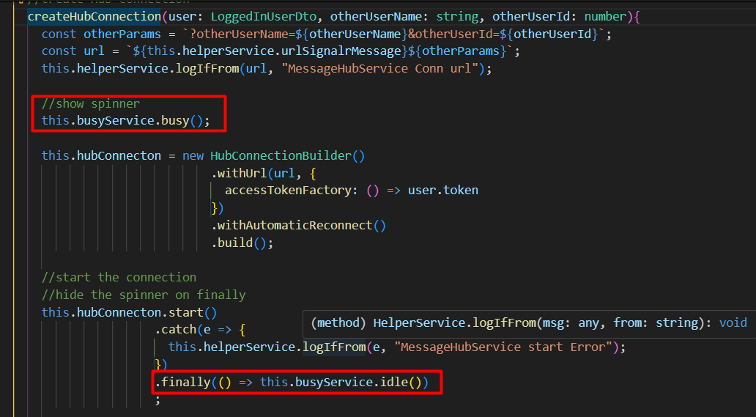

/site/members/member-messages

member-messages.component.html
fix the scrolling by moving the scrolling to the card-body
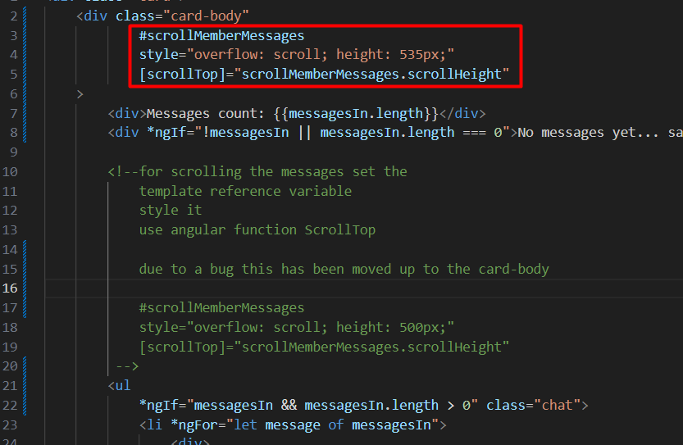
And also disable the Send button while the message is being sent

member-messages.component.ts
set a var for isLoading
isLoading = false;

and the update the submit message method
OnSubmitMessageUsingHub(){
if(!this.memberIn || !this.memberIn.id){
this.toastr.error('User error', 'Error');
return;
}

this.isLoading = true;
//this is returning a promise
//The newly added message will show via loadMessagesFromMessageHub
this.messageHubService.createMessage(this.memberIn.id, this.messageContent)
.then(() => {
this.msgForm.reset();
})
.finally(() => this.isLoading = false )
;

}

Production Build

Build
Issue command
> ng build
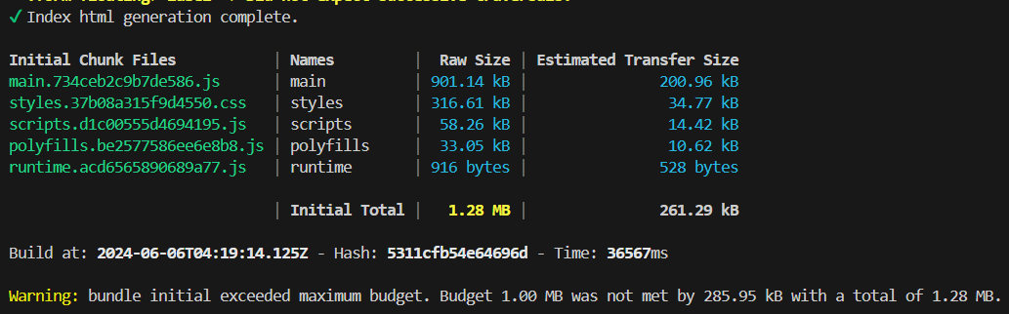
And the files pushed to wwwroot folder
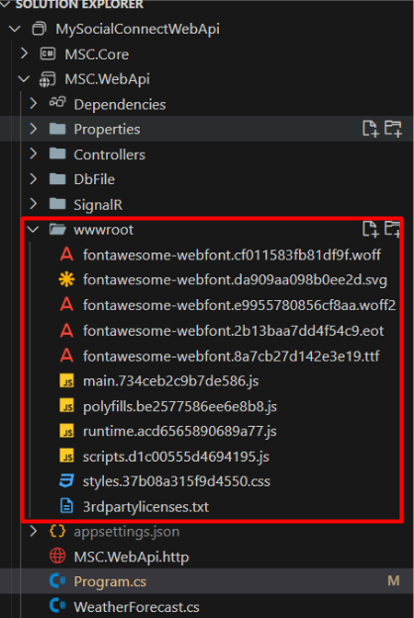

Build Warning

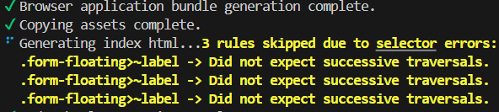

Add optimizations to the angular.json for production
"optimization": {
"scripts": true,
"styles": {
"minify": true,
"inlineCritical": false
},
"fonts": true
}

Full thing
"configurations": {
"production": {
"budgets": [
{
"type": "initial",
"maximumWarning": "1mb",
"maximumError": "2mb"
},
{
"type": "anyComponentStyle",
"maximumWarning": "2kb",
"maximumError": "4kb"
}
],
"fileReplacements": [
{
"replace": "src/environments/environment.development.ts",
"with": "src/environments/environment.ts"
}
],
"outputHashing": "all",
"optimization": {
"scripts": true,
"styles": {
"minify": true,
"inlineCritical": false
},
"fonts": true
}
},

